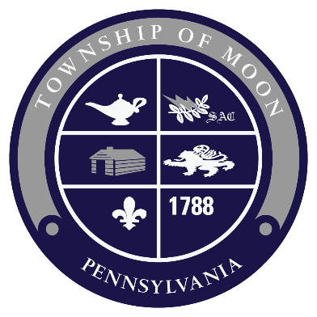
Calling All Volunteers!!!
Need Now for Moon Twp. Fall & Winter Events
Gain service hours for clubs, organizations, churches, scouts and be engaged in our community!

- Wizarding Festival at Moon Park – Saturday, September 8, 2018 (2-6 pm) Moon Park – calling all wizards and witches – run a booth or game, help with set up – costumes recommended!
- Halloween Spooktacular, Wednesday, October 24, 2018 (4-6:30 pm) Moon Park- come in costume to help with face painting, games, pumpkin painting, trick or treat trail, hayrides or DJ dance party.
- Trail Building – all Parks – weekends and as scheduled
- Moon Twp. Light Up Night – Thursday, Nov 29, 2018 (5-8pm) Municipal Bldg., help with games, rides, booths, kid’s show, Santa’s arrival and tree lighting.
- Breakfast with Santa – December 10, 2019

Email aottaviani@moontwp.us or Call 412-262-1703 ext. 402

